JAVA – DAY 5:

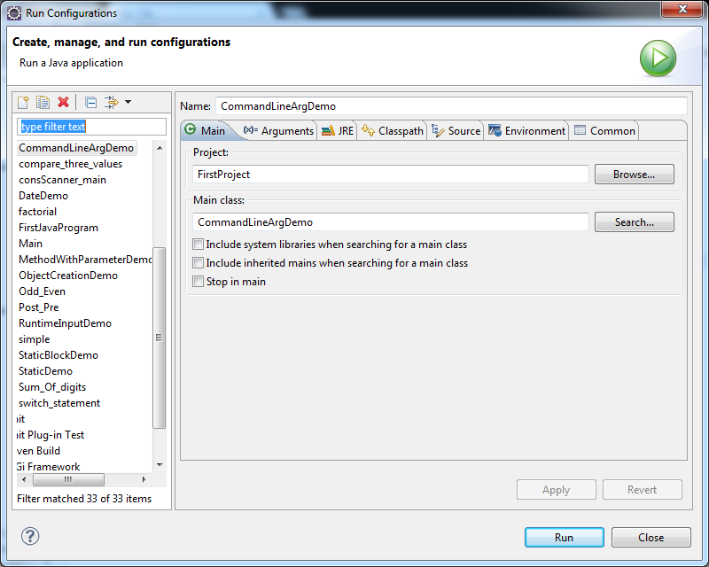

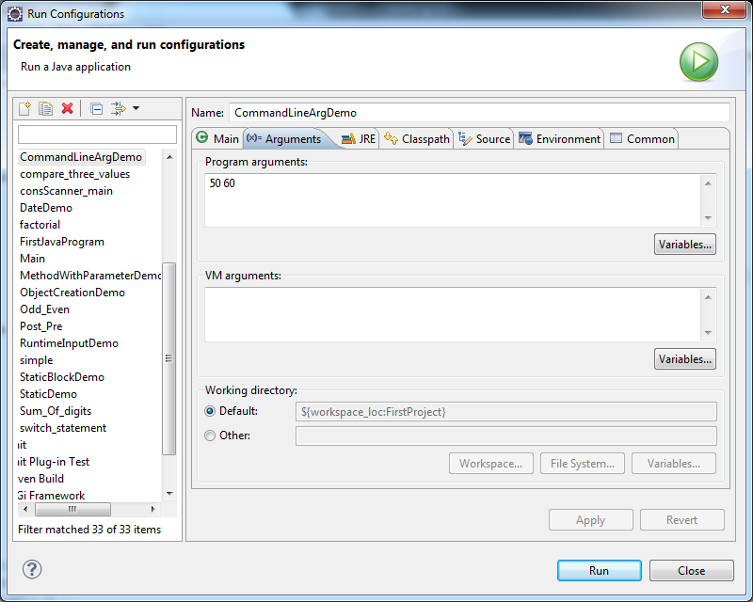

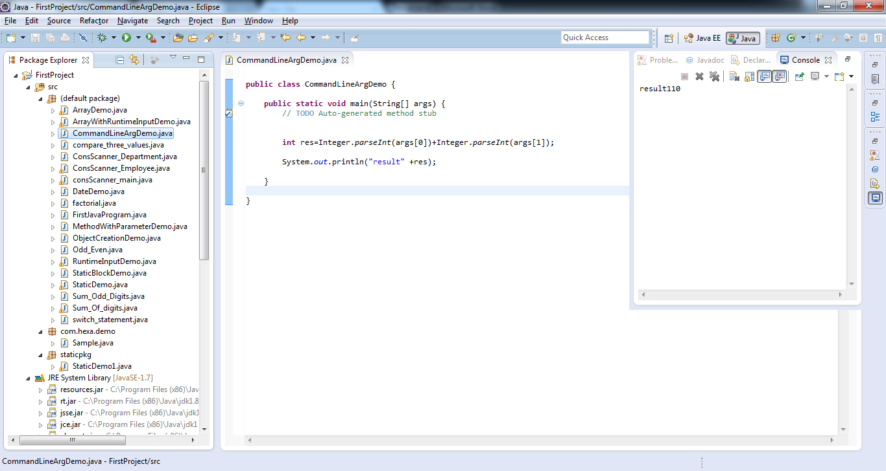

METHOD OVERLOADING:

//-Advantage - calling is easy, because all the methods are with same name

//m.cal(10, 20);

//give f next to float

//m.cal(10.5f,11.5f);

//m.cal(10,20,30);

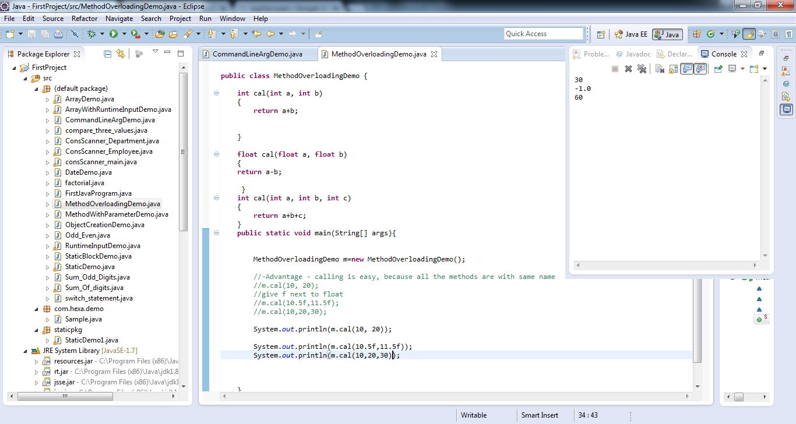

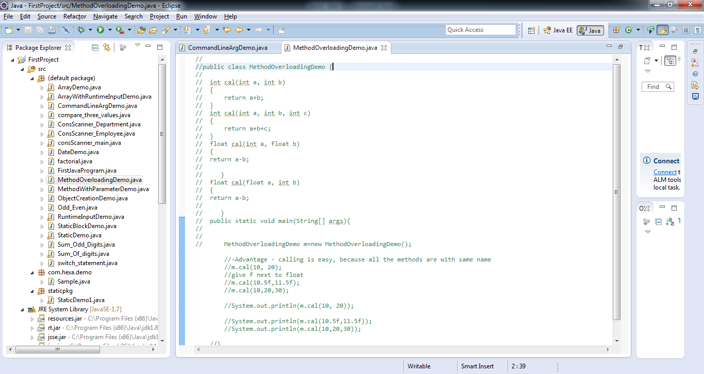

**Inhertiance –DEMO:**

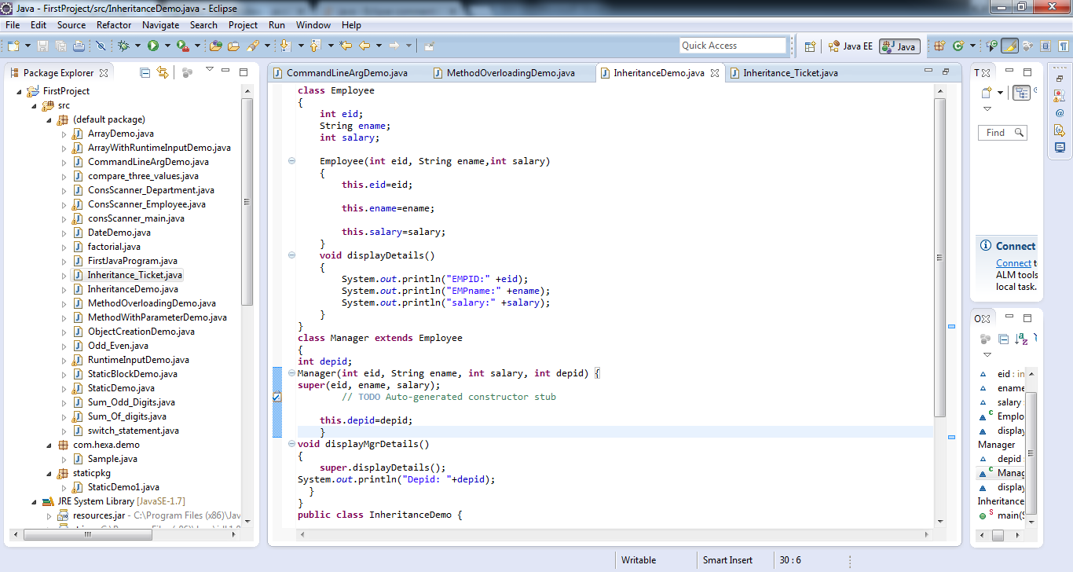

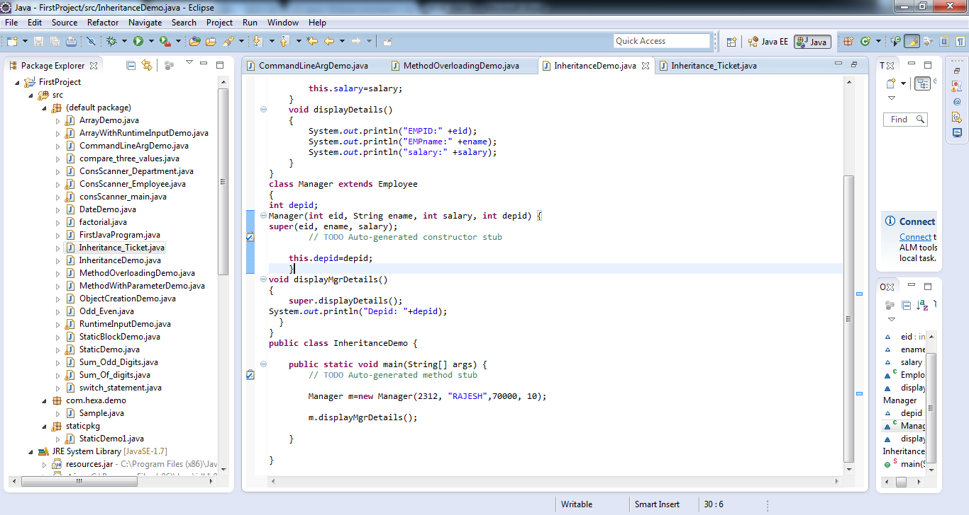

**Inheritance Exercise:**

**Ticket- Tid, Source, Destination.**

**Extend the class with Confirmed Ticket and Requested Ticket**

**Confirmed Ticket-has “SEAT NUMBER” as it’s own attribute**

**Requestd Ticket - has “REQUESTED TICKET” as it’s own attribute**

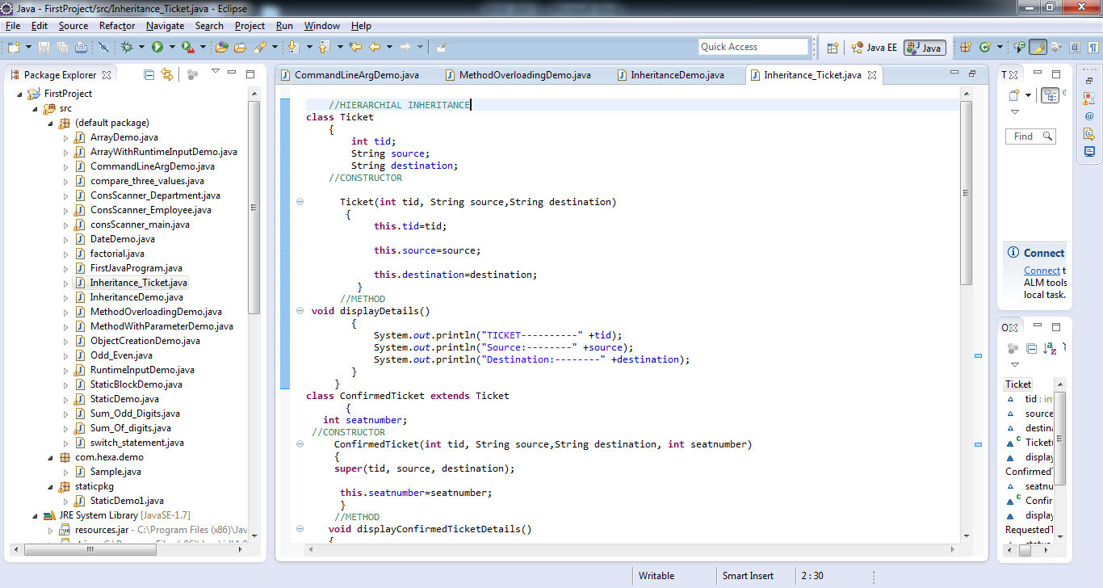

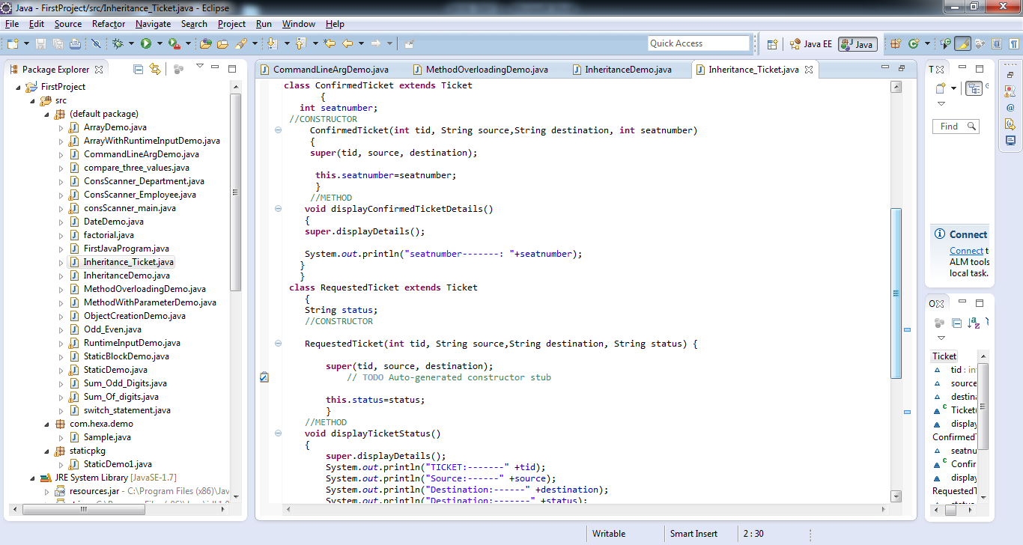

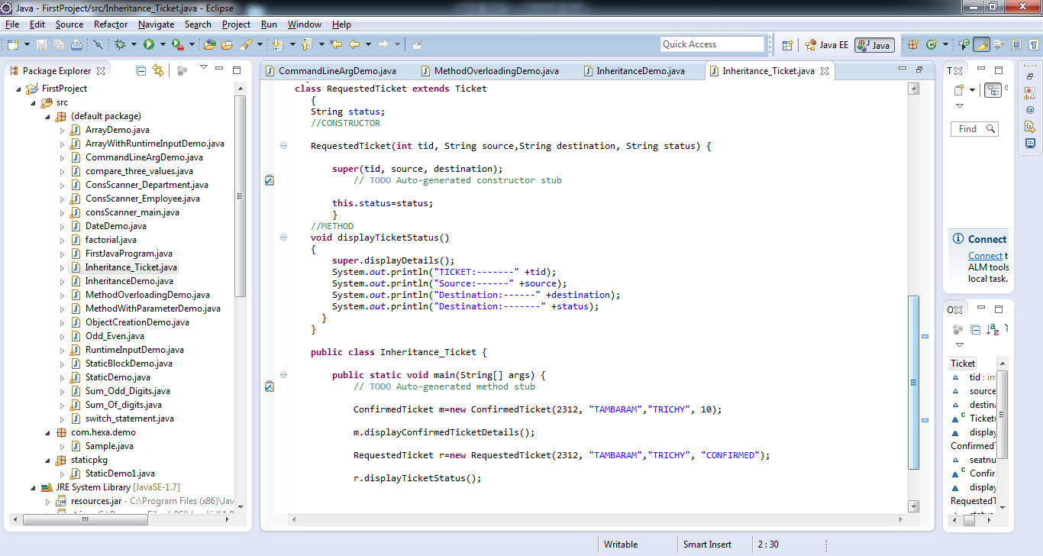

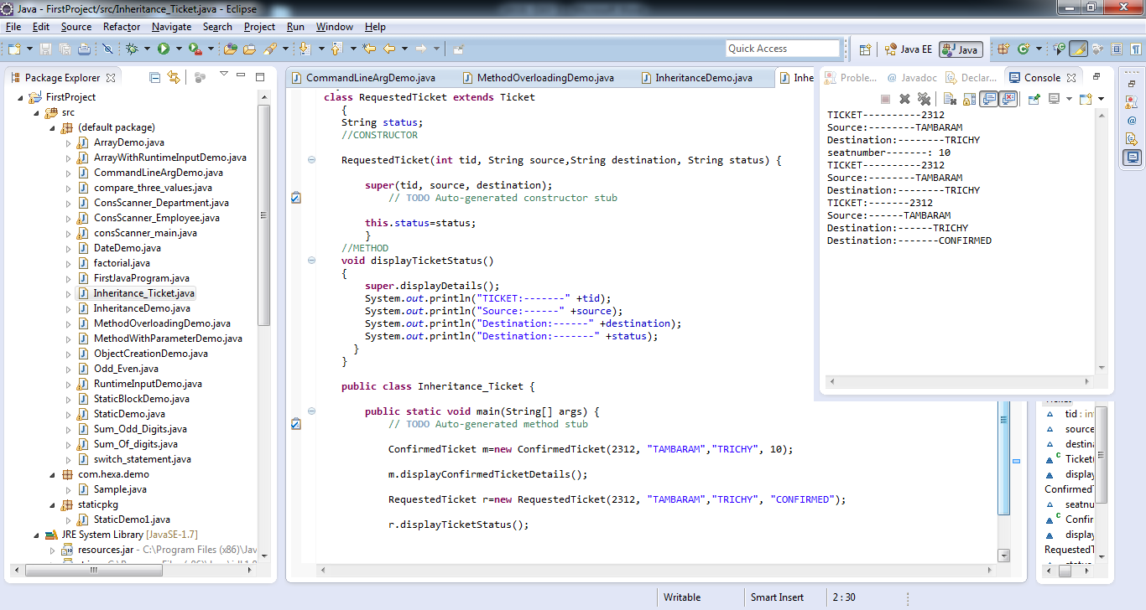

**ACCESS SPECIFIER:**

1.Private (Within the class)

2.Public(anywhere in the class)

3.Protected(only for subclass irrespective of packages)

4.Default(Can be accessed within the package)